Question 2

The impact of dividend event on stock equity

Part 1 - Event Description

The dividend payout ratio is the ratio of the total amount of dividends paid out to shareholders relative to the net income of the company. It is the percentage of earnings paid to shareholders via dividends. The amount that is not paid to shareholders is retained by the company to pay off debt or to reinvest in core operations. It is sometimes simply referred to as simply the payout ratio.

Since this event is usually a major benefit for stock holders, the purpose of this group of studies is to study the net worth curve of stocks before and after this event occurs. The sample of the study is all the stocks of Shanghai A-shares.

Part 2 - Data Processing

1Cumulative Return

1.1Data Preprocessing

Convert the time series data in Excel into the number of days between this day and 2010-1-1, so as to import such data into the numerical matrix of Matlab.

Example：

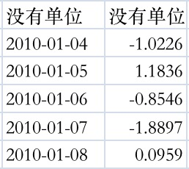 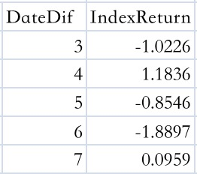

The missing data on the dividend date will be treated as if the date of the day is 0, so this set of data will be automatically ignored in the program.

1.2Code Logic

The code file name(import_data,construct revenue_matrix,plot_curve)

1.2.1Construct revenue_matrix——Rit

Because there are more than 200,000 sets of time series data of the daily return of individual stocks, Excels are divided into three(2010-2014，2015-2019，2020-2021). The first step of the code is to combine three stocks with the same stock serial number in Excel into a final_matrix.

The second step of the code is to find the dividend date corresponding to each stock serial number, and then go to the composite matrix to find the position of these dividend days, and construct the position_matrix.

The third step is to find the return rate data of the corresponding stock within [-10,10] according to the position_matrix, and construct the revenue_matrix. Put the data of ten days before and after a dividend event in the same row, so the matrix has 21 columns.

Since excel1, 3, and 5 correspond to stock serial numbers of 600000-601600, and excel2, 4, and 5 correspond to stock serial numbers of 601600-603999, the Rit matrix is used to merge the two sets of data to obtain the final matrix within [-10,10] days ——Rit.

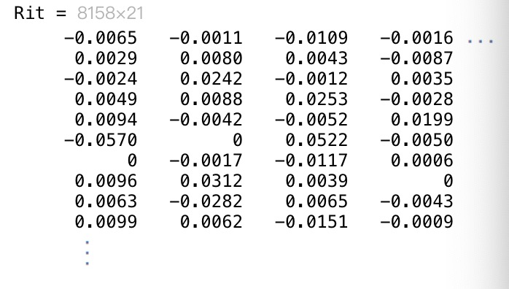

1.2.2Enhance Code Resilience

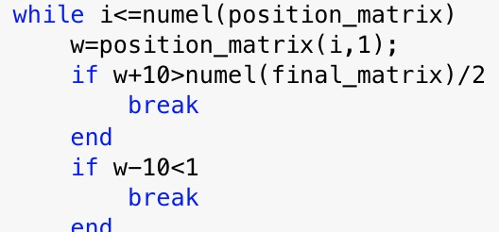

This part of the code is used to eliminate data that is not available before and after the event. For example, if the event occurred on 2021.12.1, the data for the next ten days does not exist, and the data within 10 days after the event cannot be found, so it needs to be eliminated.

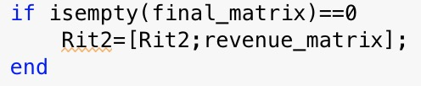

This part of the code is to prevent the stock serial number from being discontinuous. When there is an empty matrix, it will not be added to the Rit matrix.

1.2.3Plot the cumulative average yield curve

Code:

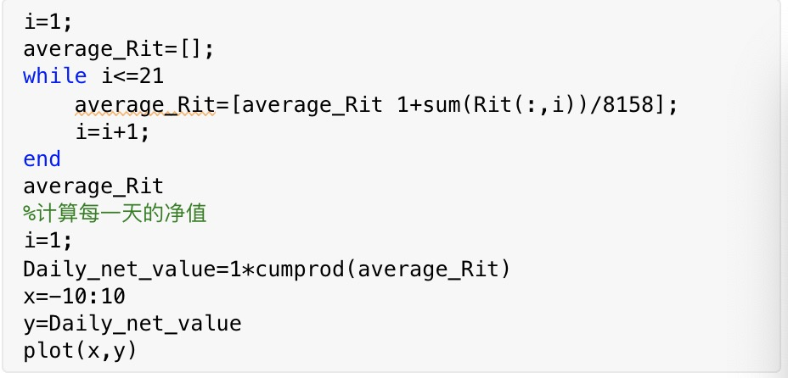

Output:

Cumulative Returns

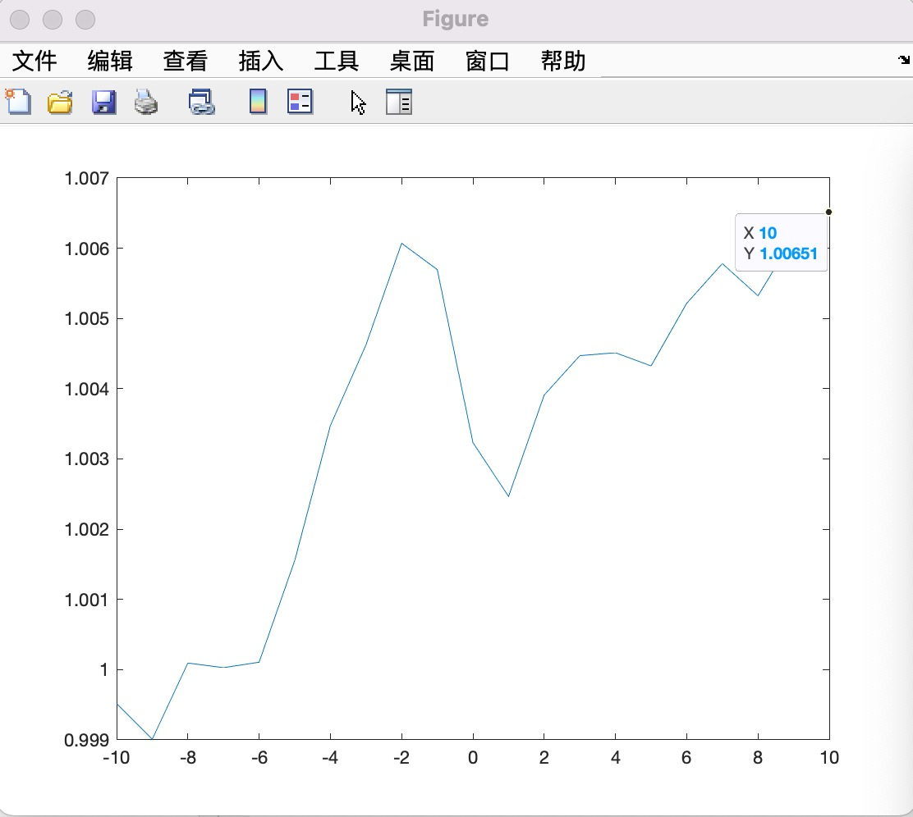

2Cumulative Average Abnormal Return and Average Abnormal Return

2.1Code Logic

2.1.1 Get b0 and b1

The code file name(CAAR,ERit)

The method of filtering the data of [-170,-20] days is the same as the logic of the previous code. The difference is that some parameters and restrictions are modified. After the final processing, the two parts of the code are combined to obtain the rate of return matrix.

After that, the return rate of [-170, -20] days before the occurrence of these events is selected through the ERMt matrix. The selecting algorithm can be used repeatedly, and only the parameters need to be adjusted.

Finally, b0 and b1 are obtained by regression processing of this part of the code.



Code:

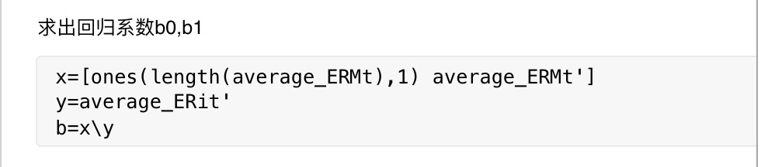

2.1.2 Draw CAAR curve

Using the same selecting algorithm, select the index return rate within the day of the event [-10,10], and use the previous linear regression coefficients to calculate the expected return rate of individual stocks within the day [-10,10], and finally calculate the AAR and draw the corresponding The net worth curve.

As the figure below shows:

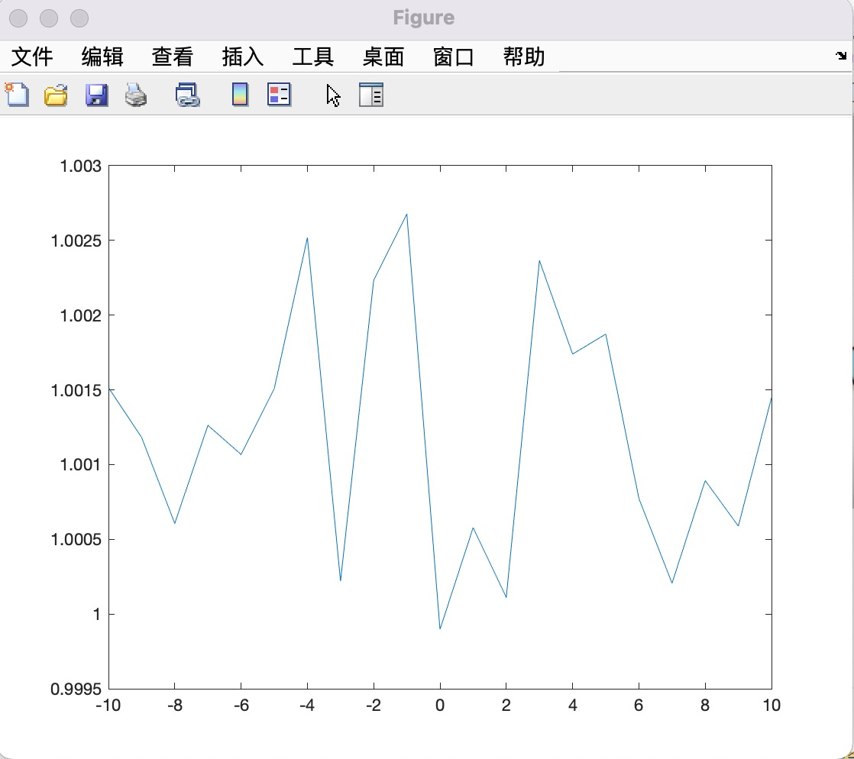

Part 3 - Conclusion

Since the image does not show excess revenue, there is no excess revenue for Dividend payout.

Part 4 - Reason Inference

Since there is a dividend announcement date before the dividend payment date, this means that the dividend payment may have become public information and be digested by the market. According to the efficient market hypothesis, since dividends have become market expectations, the stock price did not change significantly when the specific faction day came, which ultimately led to the occurrence of this event that could not bring excess returns.